**Game Project Report**

**Space Battle Rescue**

Submitted by(**CyberCrypto**)

**Team members Student Id :**

Abu Rayhan Siddike 2011046121

MD. Rayhanul Islam 2010976154

Rahat Siddique 2010876127

University of Rajshahi  
 31st December, 2021

**Abstract**

The goal of our game project is to design a 2-D graphical computer game using SFML. For our project, we decided to design a 2-D adventure game where the objective of the game is to fly outer space with an airoplane and shoot enemies plane and solve some mathematical or logical problems. The user, played as a pilot, has to fly that airoplane, shoot and solve problems without being hit by enemy’s aircraft. The game is designed in a Windows environment and written in C++ SFML with the use of Visual Studio. For our project, we have implemented several STL and SFML programming functions. As a result, we have created a 2-D adventure game that is entertaining and enjoyable.

All the features that we said we’re going to implement in our game such as adding several levels, give our player the experience of flying in the outer space, new airoplane and arena in every new level are included in our game. But we missed one feature that is if player passes a stage he had to solve some mathematical or logical problems to go on the next stage. We thought it would be boring to add study in an entertaining game. That’s why we skipped it. Despite it, our game is all OK and ready to give a player entertainment and experience of outer space view. Two picture is given below showing how our game looks :

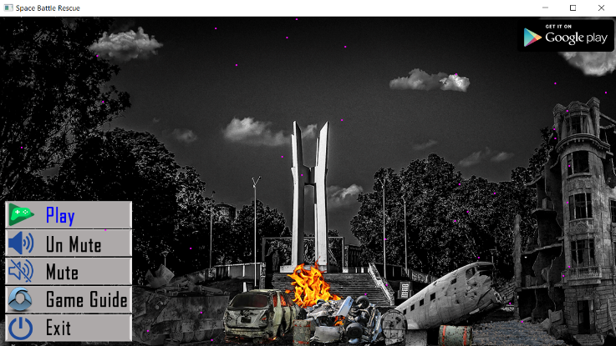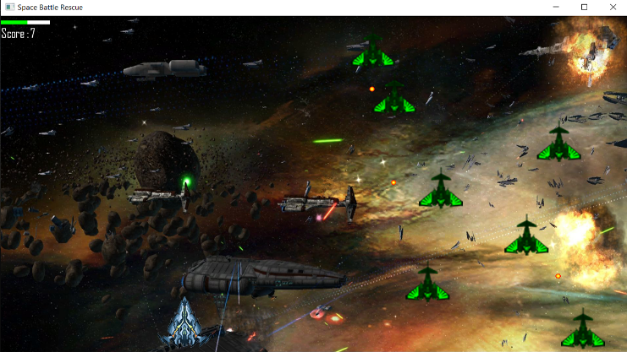

**Game Diagram**

**Application close**

**Death**

**Score**

Powerful Enemy ships

plane upgrade  
New arena

Player/Enemy/  
Animation

Game  
Guide

Enemy spaceship increases

Unmute

Mute

**Start**

Try again

**Implementation**

We used C++ to perform our game project. Many STL and SFML functions are used to complete our project.

At first we connected our program with window with the help of RenderWindow class. The Render window is used to export the currently displayed graphics scene to an image file or to a geometric scene description file suitable for use by one of several external renderers, which can produce a final image. We created a menu in our game to control our whole gameplay. We used SFML provided classes such as Texture, Sound buffer, Font, Text, Different types of shape (we specially used circle and rectangle shape), which has made our game smooth and enjoyable to play. We also used base_enemy class and created a random method properties for our enemies. They appears randomly in our display and shots at front straight. We then used “event” union. Mainly vector was used from many several STL functions along with some other STL functions also.

A code segment of collusion between our airoplane and enemy plane is given below :

for (size_t i = 0; i < sprite_bullet_pictures.size(); i++)

{

for (size_t k = 0; k < sprite_enemies.size(); k++)

{if(sprite_bullet_pictures[i].getGlobalBounds().intersects(sprite_enemies[k].getGlobalBounds()))

{sprite_enemies.erase(sprite_enemies.begin() + k);

sprite_bullet_pictures.erase(sprite_bullet_pictures.begin() + i);

score++;

text_score.setString(to_string(score));

health.setSize(sf::Vector2f(health.getSize().x + 2.f, 8.f));

if(un_mute)

sound_explosion.play();

break;

}}}

Here, if our airoplane’s bullet hits enemy aircraft, then they are erased and with this function – sprite_ememies.erase(), as well as bullet is also erased with sprite_bullet_pictures.erase() function. We did tried to make them look blasted when they are hit but couldn’t do so. Then if the sound condition is unmuted then the player can hear the collusion sound and explosion sound with sound_explotion.play() function.

**User Manual**

The player controls the game play using particular keys on the keyboard and mouse.

**Direction Keys:**

* Key ‘w’: Move the plane forward
* Key ‘s’: Move the plane backward
* Key ‘a’: Move left
* Key ‘d’: Move right

**Other:**

* Press the left mouse key to shoot.

**Future plan :**

1. We are willing to make it a 3-D game.
2. We will use moving pictures such as gif file to make it more realistic.
3. If we find, adding study in it will be fine with the players, then we will add age based problem in it. That means problem will be set according to the age of player.
4. Better user interface will be added to make it more enjoyable, like long press to shoot instead of single pressing every time.
5. Better visual effects and sound effects will be added.

**Reference :**

1. For our game project, we learn SFML form a Youtube page name “Sonar Systems”. The link of this page is given below : https://www.youtube.com/watch?v=FLpD54gx_5w&list=PLRtjMdoYXLf776y4K432eL_qPw4na_py3&fbclid=IwAR3kE4qI_2yI409V28AEauW0fLbKtKg3wKxbgyd6070avBXHP5mbiqgk-sQ
2. All images were collected from google.com and then we edited it according to our need.